The Counselor’s Corner

**MRS. BARNHARDT**

**NEMO VISTA ELEMENTARY**

**Spring 2021**

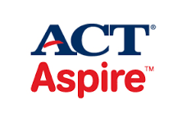

**Our 3rd-5th grade students will be participating in the ACT Aspire standardized test again this year. Our teachers and students have worked hard to prepare for this! Students will be tested on Math, Science, Reading, English and Writing during these assessments. The testing dates are under the Upcoming Events section on this newsletter. Please make every effort to have your student here on their testing days. If a doctor’s appointment is unavoidable, please make it in the afternoon.**

**Upcoming Events**

April 6 3rd-5th Aspire Testing

April 7-8 5th Aspire Testing

April 12-13 4th Aspire Testing

April 14-15 3rd Aspire Testing

April 19-21 3rd-5th Aspire for Virtual Students

April 26-30 K-2nd MAP testing

May 3-7 3rd-5th MAP testing

MC900153632[1]

MC900354059[1]

**Spring Character Words**

March – Courage

April – Trustworthy

May – Respect

