The Counselor’s Corner

**MRS. BARNHARDT**

**NEMO VISTA ELEMENTARY**

**WINTER 2020/2021**

**Classroom Guidance**

Talk to your child about what they are learning during classroom guidance lessons.

MC900436161[1]



**Upcoming Events**

January 11-15 K-2nd MAP Testing

January 18-22 3rd-5th MAP Testing

**C:\Users\bbarnhardt.NEMOVISTA\AppData\Local\Microsoft\Windows\Temporary Internet Files\Content.IE5\FZXJAGH1\MC900323014[1].wmf**

**Winter Character Words**

December – Compassion

January – Acceptance

February – Citizenship

Mental Health

Here are some ideas for you on self- care and mental health for children.



**Recommended Reads**

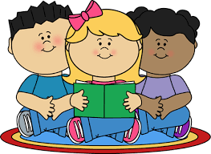

Reading with your child is great quality time and will help strengthen their reading skills. Here are some great suggestions:

Compassion: The Giving Tree by Shel Silverstein

Acceptance: The Sneetches by Dr. Seuss

Citizenship: Have You Filled a Bucket Today? by Carol McCloud