The Counselor’s Corner

**MRS. BARNHARDT**

**NEMO VISTA ELEMENTARY**

**OCTOBER 2017**

**College & Career Week**

**This year the theme for our Career Fair is “Keep Your Future Healthy” and will feature health related careers. Our 4th grade students will visit UCA and our 5th grade students will visit ATU. We will also have our career dress up day for all students. Students are encouraged to dress up as what they want to be when they grow up.**



**Upcoming Events**

October 17 - Lunch Bunch

October 23-27- Red Ribbon Week

Nov 27-Dec 1-College & Career Week

November 28-5th Grade to ATU

November 29-Career Fair 3rd-5th

November 30-4th Grade to UCA

December 1-Career Dress Up Day

December 12- Lunch Bunch

MC900153632[1]



**Character Words**

October - Self-Control

November – Responsibility

December-Compassion

**Red Ribbon Week October 23-27**

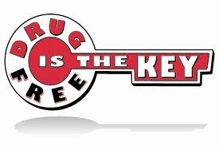

**Monday- Ropers Aren’t Dopers**

**Wear Cowboy/Cowgirl Gear**

**Tuesday-Hats Off to Being Drug Free!**

**Crazy Hat Day**

**Wednesday- Lights, Camera, Drug Free!**

**Dress like TV/Movie Character**

**Thursday- Don’t Let Drugs Mix You Up!**

**Miss Match Day**

**Friday – “Red”y to Live a Drug Free Life!**

**Wear Red Clothing**