The Counselor’s Corner

**MRS. BARNHARDT**

**NEMO VISTA ELEMENTARY**

**SEPTEMBER 2018**

**Counselor Website**

Check out my tab on the school website! I have lots of different information, tools and games for you and your student. If you have any websites you find useful, please let me know so I can possibly add them!



**Pop Tab Pandemonium**

We will be collecting pop tabs for Ronald McDonald House again this year. These can be from soda cans, vegetables, tuna etc… The winning grade will receive an award. More information about this will come out later.

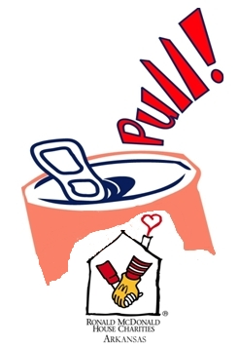

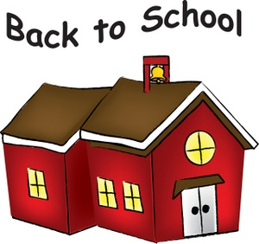

**Character Words**

September - Honesty

October - Self-Control

November - Responsibility



If your child needs weekly ongoing counseling, please call and discuss your options with me. We have an outpatient counselor from The Pointe that comes to our school to see students each week. This is very beneficial because students don’t have to be checked out of school to see a counselor off campus which adds to their absences. If you are interested in this service, please call me to discuss.